**Brand Name**

Handbag Design Brief (Autumn/Winter 2018) - 01/02/17

Brand overview:

* **Market Level:** Premium
* **Customer:** 30-55 Female | Creative Professional
* **Brand Character:** Retro Minimalistic | Quirky Edge |Statement feature | Stylish |Practical & Functional
* **Price point:** £300 - £700
* **Materials:** Premium Leather | Suede
* **Aspirational Brands:** Marni |The Row | Lanvin

Styling direction / inspiration images:

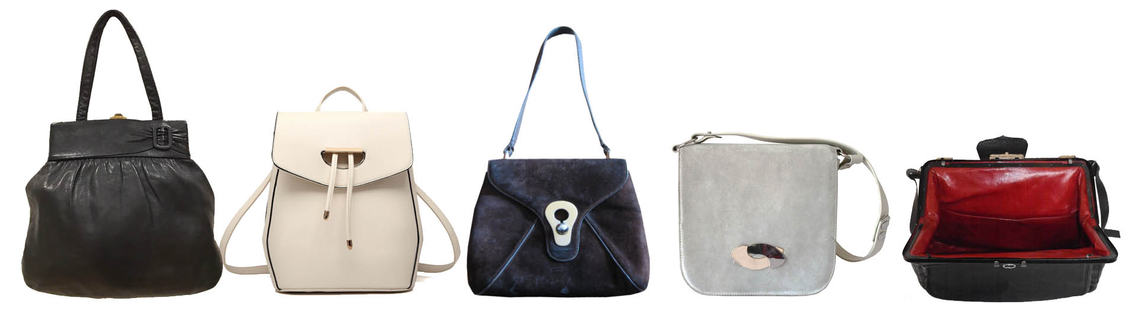

**Product Brief**

**1 x HOBO BAG**

**Main features:**

* 1 x statement feature / hardware
* Soft construction
* Easy access zip pocket on back
* To fit A4 folder
* Body Fabric: Black Leather
* Lining: Red Suede

**Inside features**:

* Brand logo - debossed silver foil print
* Ipad slip pocket
* Mobile / cell phone pocket
* Removable coin pouch

**1 x UNDER ARM BAG**

**Main features:**

* 1 x statement feature / hardware
* Adjustable strap (under arm & cross body)
* Soft construction
* Easy access zip pocket on back
* 22cm H x 28cm W
* Body: Purple Suede & Leather Mix
* Lining: Red Suede

**Inside features**:

* Brand logo - silver metal plate
* Mobile / cell phone pocket
* Removable coin pouch

**1 x BACKPACK**

**Main features:**

* 1 x statement feature / hardware
* Grab Handle
* Easy access zip pocket on back
* To fit A4 folder
* Body Fabric: Soft Grey Leather
* Lining: Red Suede

**Inside features**:

* Brand logo - debossed silver foil print
* Ipad slip pocket
* Mobile / cell phone pocket
* Removable coin pouch
* Key hook on leather tab